|  |  |
| --- | --- |
| **Practicum Case** |  |
| COMP6708  Object Oriented Programming |
| **Computer Science** | **O221-COMP6708-RV01-03** |
| ***Valid on*** *Odd Semester Year 2021/2022* | **Revision 00** |

## Learning Outcomes

* The main features of OOP
* A program using additional features of OOP

## Topic

* Java Collection

## Subtopics

* Static Array
* Collection
* List / ArrayList / Vector
* HashMap

## Soal

*Case*

**BlueJack Share**

**BlueJack Share** is a wonderful charity event that lets people get something based on each other’s charity number. Alice is the person who held the event, therefore she asked you to make a simple program using **Java Programming Language** to help her note down the participants of BlueJack Share.

* In the beginning, the program will show the title



* The program will consist of 4 menus:

1. Start Sharing
2. Update Participant
3. Delete Participant
4. Close App

* The program will ask the user to input choose menu which must be **between 1** and **4**

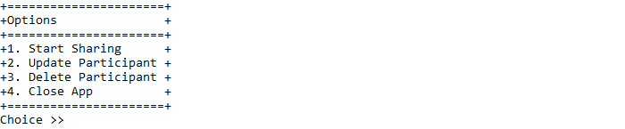

* If the user chooses menu 1, then:
* The program will ask the user to input participant details, which consist of:
* **Share Number**, which must be **numeric** and **between 0** and **100**
* **Username**, which **length** must be between **5** and **20 characters** and **unique**
* After fulfilling all validation, the program will display inputted participant data

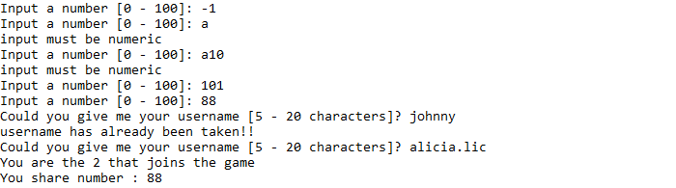

* After that return to the main menu
* If the user chooses menu 2, then:
* If there is **no participant**, then return to the main menu
* Otherwise, the program will:
* Display list of participant data
* Ask the user to input updated data, which must be **numeric** and **between** **0** and **count of data**

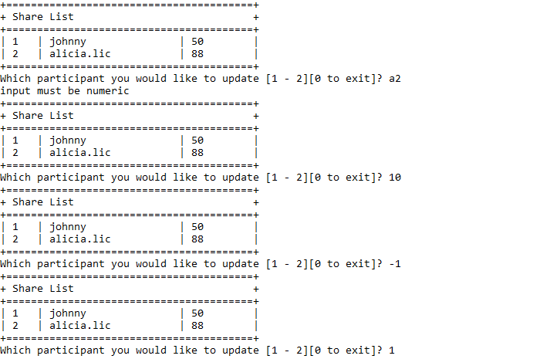

* If the input **updated data is 0**, then return to the main menu
* Otherwise, the program will:
* Ask the user to input number, which must be **numeric** and **between 0** and **100**
* Update the **selected** participant share number data

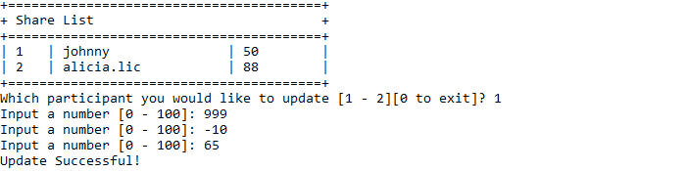

* If the user chooses menu 3, then:
* If there is **no participant**, then return to the main menu
* Otherwise, the program will:
* Display list of participant data
* Ask the user to input deleted data, which must be **numeric** and **between** **0** and **count of data**

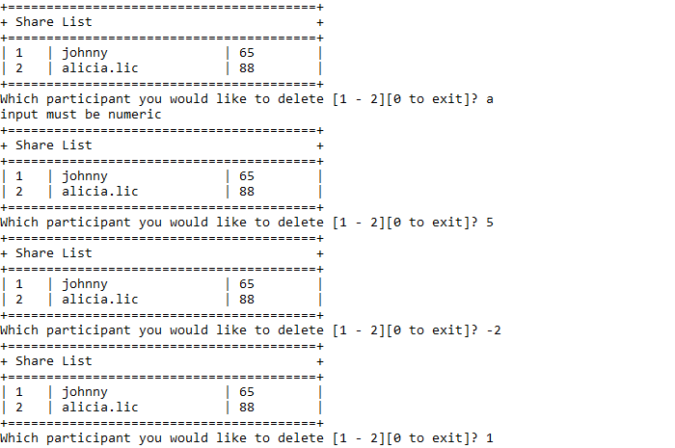

* If the input **deleted data is** **0**, then return to the main menu
* Otherwise, the program willdeletethe **selected** participant data

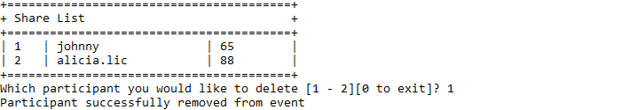

* If the user chooses menu 4, then:
* Determine the game resultwith the following step (using **the Collection Interface** method):
* First, **sort** the username of participant in **ascending** order
* Second, **shuffle** their share number and **reverse** the order at the end
* Display the game result that consists of the participant username with their pickedshared number and the final number after being shuffled and reversed

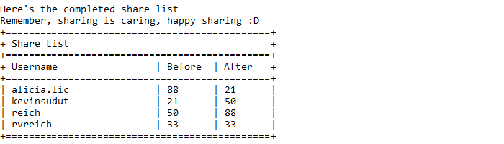

* The program will be closed

**Please ask your teaching assistant if there are any related questions.**